Logic manipulation-simplification-circuits Homework

Paul Collado

Department of Computer Science

Montclair State University

CMPT280

Assembly Language

10/14/2014

1. Problem: Manipulation of Boolean Expressions

Using logic algebraic manipulations prove the following relations:

1. !A + AB + A!C + A!B!C = !A + B +!C

!A + AB + A!B!C + A!C + A!B!C = added A!B!C

!A + A(B + !B • !C) + A!C(1 + !B) = Factor A and A!C

!A + A(B + !C) + A!C • 1 = Using formular A + !AB = A + B

!A + A(B + !C + !C) = Factor A and simplify Cs

!A + A(B + !C) = Using formula !A + AB = !A + B

!A + B + !C = !A + B + !C Final result

1. Y!Z + !X!Z +!X!Y = Y!Z + !X!Y

Y!X + Y!Z + !X!Z + !Z + !X!Y = distribute Y and simplify

Y(!X + !Z) + (!X • !Z) + !Z + !X!Y = Factor Y

Y(!X + !Z) + (!X • !Z) + !Z + !X!Y = using !A + !AB = !A

Y!X + Y!Z + !Z + !X!Y = distribute Y

Y • !X + Y • !Z + !X!Y = using A + !AB = A + B

Y + !X • !Z + !X!Y = simplifying

Y!Z + !X!Y = Y!Z + !X!Y final result

1. Problem: Simple Logic Simplification

Simplify completely the following expression, using logic algebraic manipulations

Then implement using minimum number of logic gates

ABC + ABD + !AB!C + CD + B!D

B(AC + AD + !A!C + !D) + CD factor B and Simplify

B(AD + !D) + CD using !A + AB = !A + B

B(!D + A) + CD distribute B

B!D + BA +CD final result

Implementation:

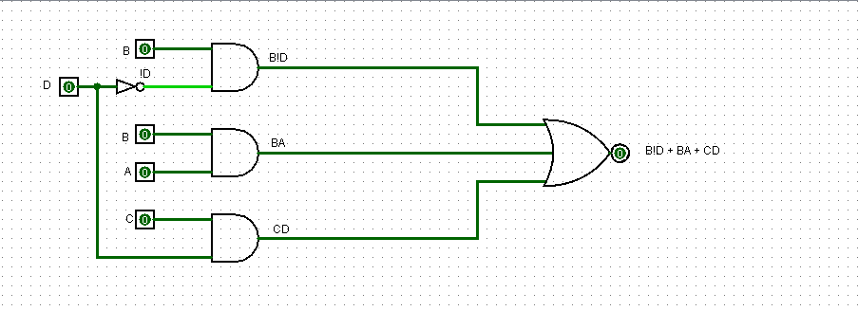

1. Problem: Simplification Using DeMorgan’s Theorem

Simplify completely the following expression, using logic algebraic manipulations

Then implement using minimum number of logic gates

1. !(AB + AC) + !A !B C

!(AB + AC) + !A !B C Using DeMorgans

!(AB) + !(AC) + !A !B C Using DeMorgans again

!A + !B • !A + !C + !A !B C Factor !A

!A(!B + !C + !B + C) Simplifying

!A •!B Final result

Implementation:

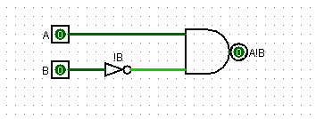

1. A !(!B + C) !(BC)

A !(!B + C) !(BC) Using DeMorgans

A(!!B • !C) $•$ (!B + !C) Simplifying

A(B • !C) $•$ (!B + !C) Distribute A

AB!C • (!B + !C) Distribute AB!C

AB!C!B + AB!C!C Simplifying

A!C + AB!C Factor A

A(!C + B!C) using !A + !AB = !A

A • !C Final result

Implementation:

